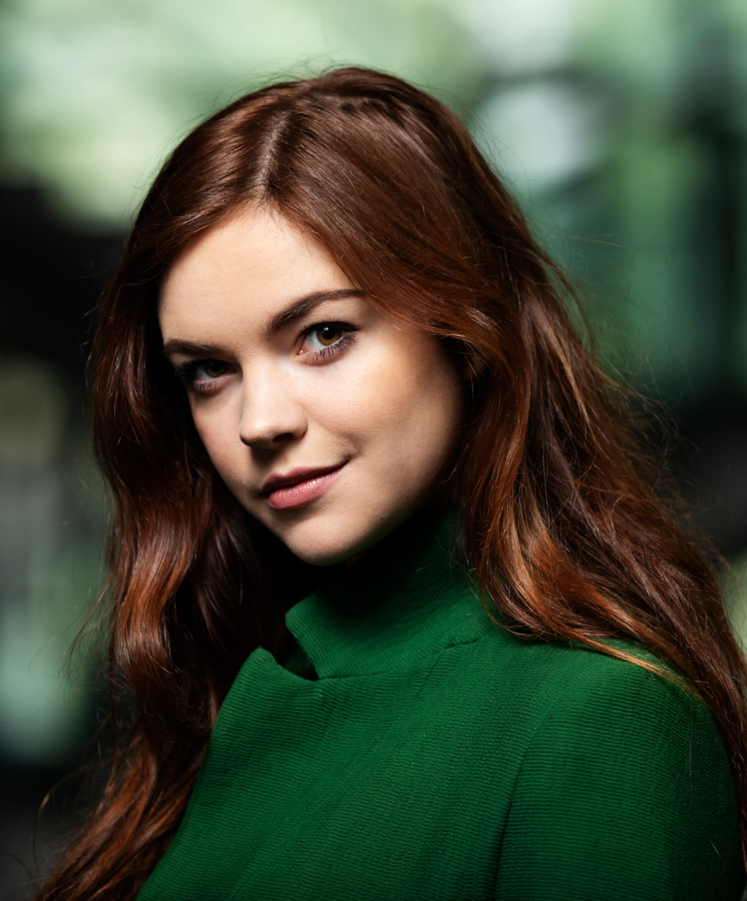
STEPHANIE TROYAK
Height: 5’7” Weight 125
Auburn hair/Hazel Eyes
stephanietroyak@gmail.com
+4915236600378
+1-972-697-6723

Television
The Greenhouse Academy Recurring Netflix
Super 35 Supporting Motimedia

Film
Molly An American Girl on the Home Front Supporting Dir. Joyce Chopra
Beyond Lead Dir. Birgit Adler-Conrad
Bella Lead Dir. Michael Golden
Camp Rock Dancer Dir. Matthew Diamond

Theater
Macbeth Lady Macbeth Tanztheater Wuppertal Pina Bausch
The Seven Deadly Sins Anna (Lead) Tanztheater Wuppertal Pina Bausch
Bluebeard Yolanda Tanztheater Wuppertal Pina Bausch
Palermo, Palermo Barbara Tanztheater Wuppertal Pina Bausch
Bon Voyage, Bob Stephanie Alan Lucien Oyen, TTWPB
Arien Regina Tanztheater Wuppertal Pina Bausch
1980 Aida Tanztheater Wuppertal Pina Bausch
Carnations Julie Tanztheater Wuppertal Pina Bausch
Sleep No More Lady Macbeth Punchdrunk
Training
Margie Haber Studios Advanced Acting Robin Dale Meyers
Margie Haber Studios Master Intensive Margie Haber
New York University Scene Study, Monologues Frank Deahl
New York University Acting Technique Kay Cummings
NYU Tisch BFA in Dance Minor in Acting, Minor in Business Studies
Actors Studio, London Acting for the Camera JoAnn Endicott
Batsheva Dance Company Contemporary Dance Ohad Naharin
Next Step Dance Jazz, tap, ballet, hip hop, musical theater Michelle Stafford
Booker T. Washington HSPVA Acting, choreography, dance Lily Weiss

Special Skills/Awards
“Faust” Best Actress Nominee 2018
Dance- contemporary, pointe, ballet, hip hop, tap, jazz, choreography, boxing, running, swimming, singing, water skiing, skiing, writing, licensed driver

